//Implement the concept of Garbage Collection
- Write a program to implement the Runtime class methods (totalMemory(),freememory(),gc())

class Sample
{
public static void main(String args[])
{
Runtime rs=Runtime.getRuntime();
System.out.println("The system total memory- "+rs.totalMemory());
System.out.println("The system free memory- "+rs.freeMemory());
rs.gc();
System.out.println("The system free memory- "+rs.freeMemory());

Sample s=new Sample();
System.out.println("The Object is created");
System.out.println("The system free memory- "+rs.freeMemory());
s=null;
rs.gc();
System.out.println("The system free memory- "+rs.freeMemory());
}
}
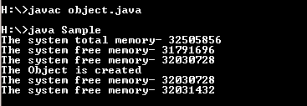

2. Write a program to implement the gc() method with user defined object.
import java.util.Scanner;
class Sample
{
public static void main(String args[])
{
Runtime rs=Runtime.getRuntime();
System.out.println("The system total memory- "+rs.totalMemory());
System.out.println("The system Free memory- "+rs.freeMemory());
rs.gc();
System.out.println("The system Free memory- "+rs.freeMemory());
Scanner ss=new Scanner(System.in);
int i=ss.nextInt();
Sample s=new Sample();
System.out.println("The Object is created");
System.out.println("The system Free memory- "+rs.freeMemory());
s=null;
rs.gc();
System.out.println("The system Free memory- "+rs.freeMemory());
}
}
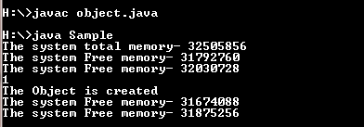

3.Write a program to implement the gc() method with user defined object and finalize method with out allocating null to the object.

class Sample
{
public static void main(String args[])
{
Sample s=new Sample();
Runtime rs=Runtime.getRuntime();
rs.gc();
}
protected void finalize()
{
System.out.println("FINALIZE");
}
}

4.Write a program to implement the gc() method with user defined object and finalize method by allocating null to the object
class Sample
{
public static void main(String args[])
{
Sample s=new Sample();
Runtime rs=Runtime.getRuntime();
s=null;
rs.gc();
}
protected void finalize()
{
System.out.println("Finalize");
}
}
